Technology Architecture

|  |  |
| --- | --- |
| DATE | 10 OCTOBER 2022 |
| TEAM ID | PNT2022TMID12733 |
| PROJECT NAME | IOT BASED SAFETY GADGET FOR CHILD SAFETY MONITORING AND NOTIFICATION |
| TEAM LEADER | ADARSH KARAN K P |
| TEAM MEMBERS | ROSHITH BABU  NARAYANAN A  THENNARASU A |

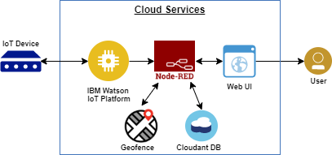

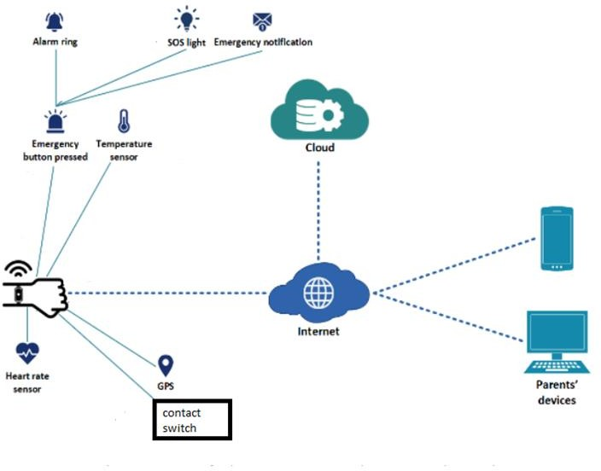

Gadget (iot device)

User(parents)

Ibm cloud

cloudant

Web/UI

Ibm watson platform

location

Node-red